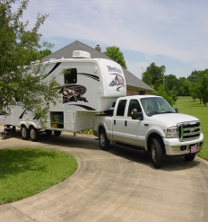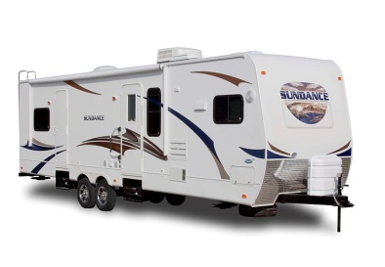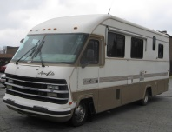

3 RIVERS SAM NEWSLETTER
APRIL 2017

FROM THE PRESIDENT:

First and foremost, a special thanks to Rose for doing such a great job as Vice-President.

You'd think I would have learned by now not to miss a meeting as it seems I get volunteered for something every time I do. Time to start cleaning out the attic, basement, garage and wherever else you stash stuff when you don't know what to do with it and get ready for the Garage Sale. I am certain that the reason that we did so well last time was because we had a LOT of really GOOD stuff. It takes time to accumulate that much, so it's not too early to start. Let your friends and families know so they can start setting things aside for you as well.

I'd also like to hear from anyone who would like to help with the planning so that we can start working on it in after Moses Lake. It was a lot of work, but I think we were all pleased with the outcome. Let's do it again!

I am attaching a letter than I received from State Director, Donna Amos, asking for responses from chapter members. Perhaps you can all look it over and turn in your responses to Rose - or maybe go over the letter as a group at the April meeting - and she can send them in to Donna or take them to Moses Lake. I think Donna is trying really hard to improve the state meetings and encourage more members to attend. She is asking for our help and I would like to see us send her some suggestions, concerns, ideas, etc.

Have a great campout in April!

Karen

Dear Presidents,
You know how important it is to keep your chapter members active, interested, and involved in chapter activities. As a President and the leader of your chapter, that is really your job to make sure that happens.
It should also be part of the job to support your State meetings as well. Your chapter members will follow you and your suggestions. After all, they elected you to lead them. So let’s talk about what it would take to get you and your chapter to the State meetings.
One suggestion I have is to schedule a campout around the State meetings. Come in early or stay after the meeting is over. All 3 places have a lot of activities to do and things to see in the area.
But please don’t schedule a campout someplace else at the same time as a State Meeting. That’s not fair to those that spend a lot of time and effort in planning the State meetings and the chapters that are selling tickets for raffles or cooking a meal all for charity.
And I would like your help in talking with your chapter members about why they don’t come and what needs to change to get them to join us.
Making suggestions sometimes feels like no one is listening. I can guarantee that your current State team members are all excellent listeners and no suggestion is left behind. So tell us what you like and don’t like, but more important tell us what you want.
1. Seminar suggestions
2. Vendors you would like to see or products you would like to see
3. Craft classes
4. Workshops
5. Games
6. Entertainment
And last, what is it that we are currently doing that you would rather we drop.
Please discuss this with your chapter, write your answers down on here and send it back to me or bring it to a State meeting. I hope your chapter will add some input but if not please send this back to me anyway with a note that they had no suggestions. Can’t imagine that but maybe.
I look forward to hearing from all of you soon.

FROM THE WAGON MASTER:

Remember the April camp out at Silver Springs Resort in Ephrata April 20-23, 2017. Joretta and the Dazeys will be hosting and acting as on-site wagon master for this camp out. Hope you all have a great time!
The campout is at the Sunny Springs RV Park in Ephrata. It is a new park. There are 16 rigs signed up to go.

Roland Mount reported that he is sending cards to members who are ill or have other significant issues. Please let Roland know if someone needs a card from the Chapter.

Char Hicks is looking for donations for the baskets.

We will hold a yard sale on the weekend of September 4, 2017 at Ron Belden’s house.

It was reported by Ron Belden that last Saturday, he, Bud Dazey, and Bob & Roxie Holley attended a meeting of the Apple Rovers. Since they were already a Winnabago group, they already have their officers.

Lew Smathers reported that the 990N IRS postcard has been filed.

Roxie Holley reported that Kadlec Hospital is trying to set up a Ronald McDonald Room at their hospital. They are looking for help in setting this up. She will follow through on this. She also reported that about ½ the people staying at the Ronald McDonald House in Spokane are from the Tri-Cities.

1st prize of $16.00 to Roxie Holley
2nd prize of $17.00 to Dwayne Ratliff
3rd prize of $18.00 to Julie Moore

Chuck Hall is in the hospital following a stroke and not doing very well. Please keep him in your prayers.

Don Mohr 4/28

Steve & Joretta Heath 4/28

PRESIDENT VICE-PRESIDENT SECRETARY TREASURER WAGONMASTER HISTORIAN
Karen Zylman Rose Moore Joretta Heath Chuck Hall Bob (Raz) Zylman Grace Hughs
737-9122 946-6895 547-3832 547-2977 737-9122 736-2043

SUNSHINE NEWSLETTER ROSTER HAPPY WHEELS
Roland Mount Gerry Hall Lewis Smathers Joretta Heath
547-2381 547-2977 547-7355 547-3832

